**Solution**

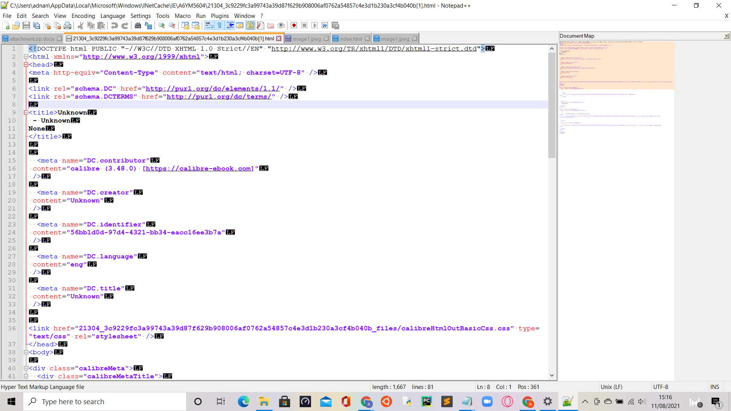

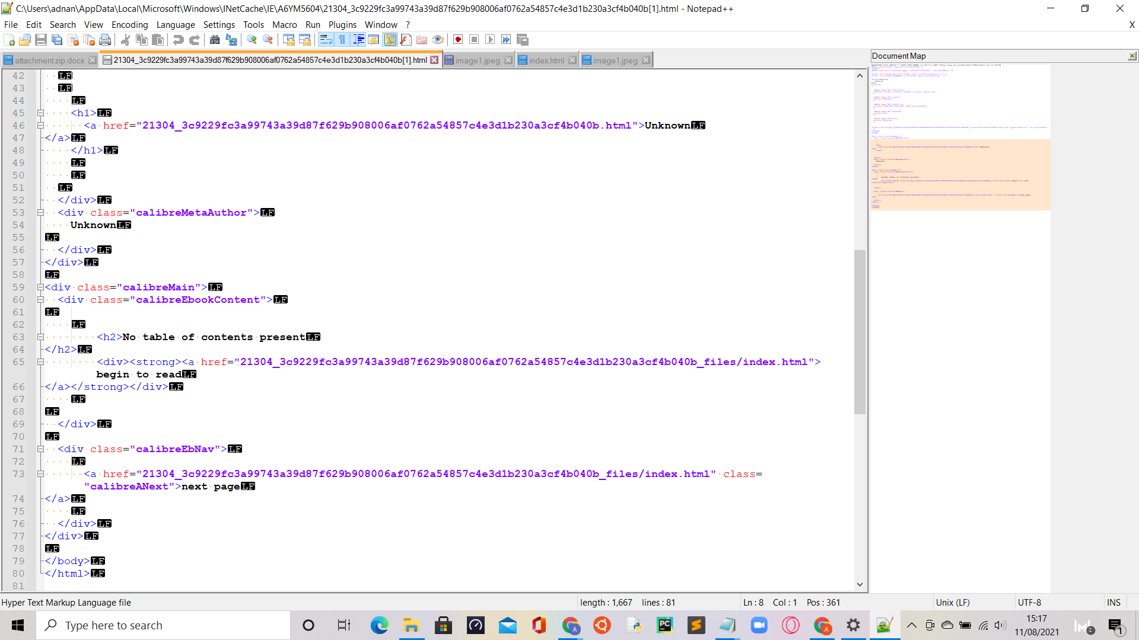

**Journal**

*Write your solution in a summary report that details the steps you took to analyse the file in question, and why, in your professional opinion, the file seems suspicious.*

1. Firstly, I converted the docx file into a zip file, using this link: <https://www.freefileconvert.com/file/POpQb2ak9LEe>
2.  Secondly, I opened the zip file using windows explorer:

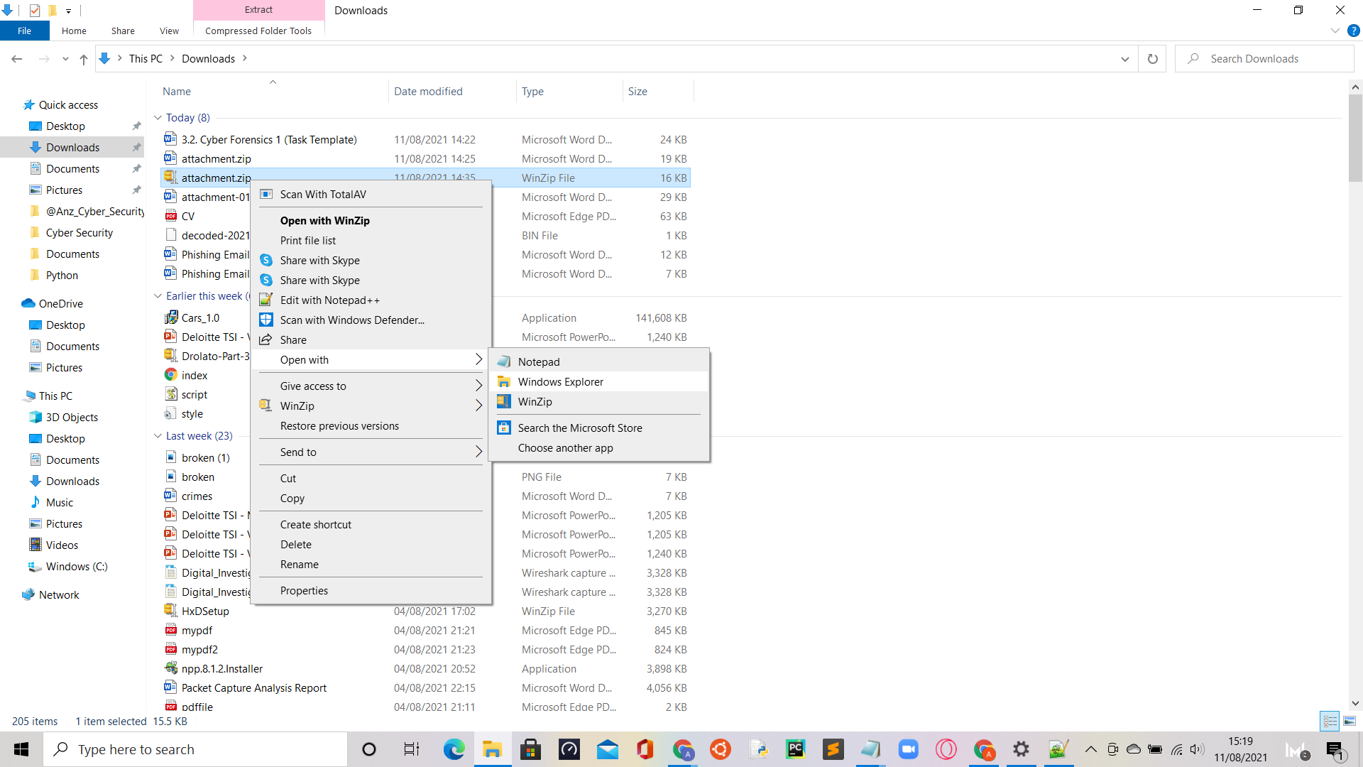

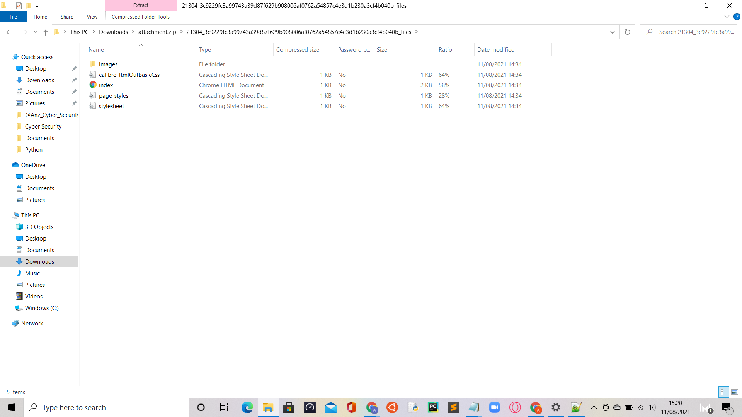

1. Next, I opened the ‘index’ file in notepad, to find several links to websites:

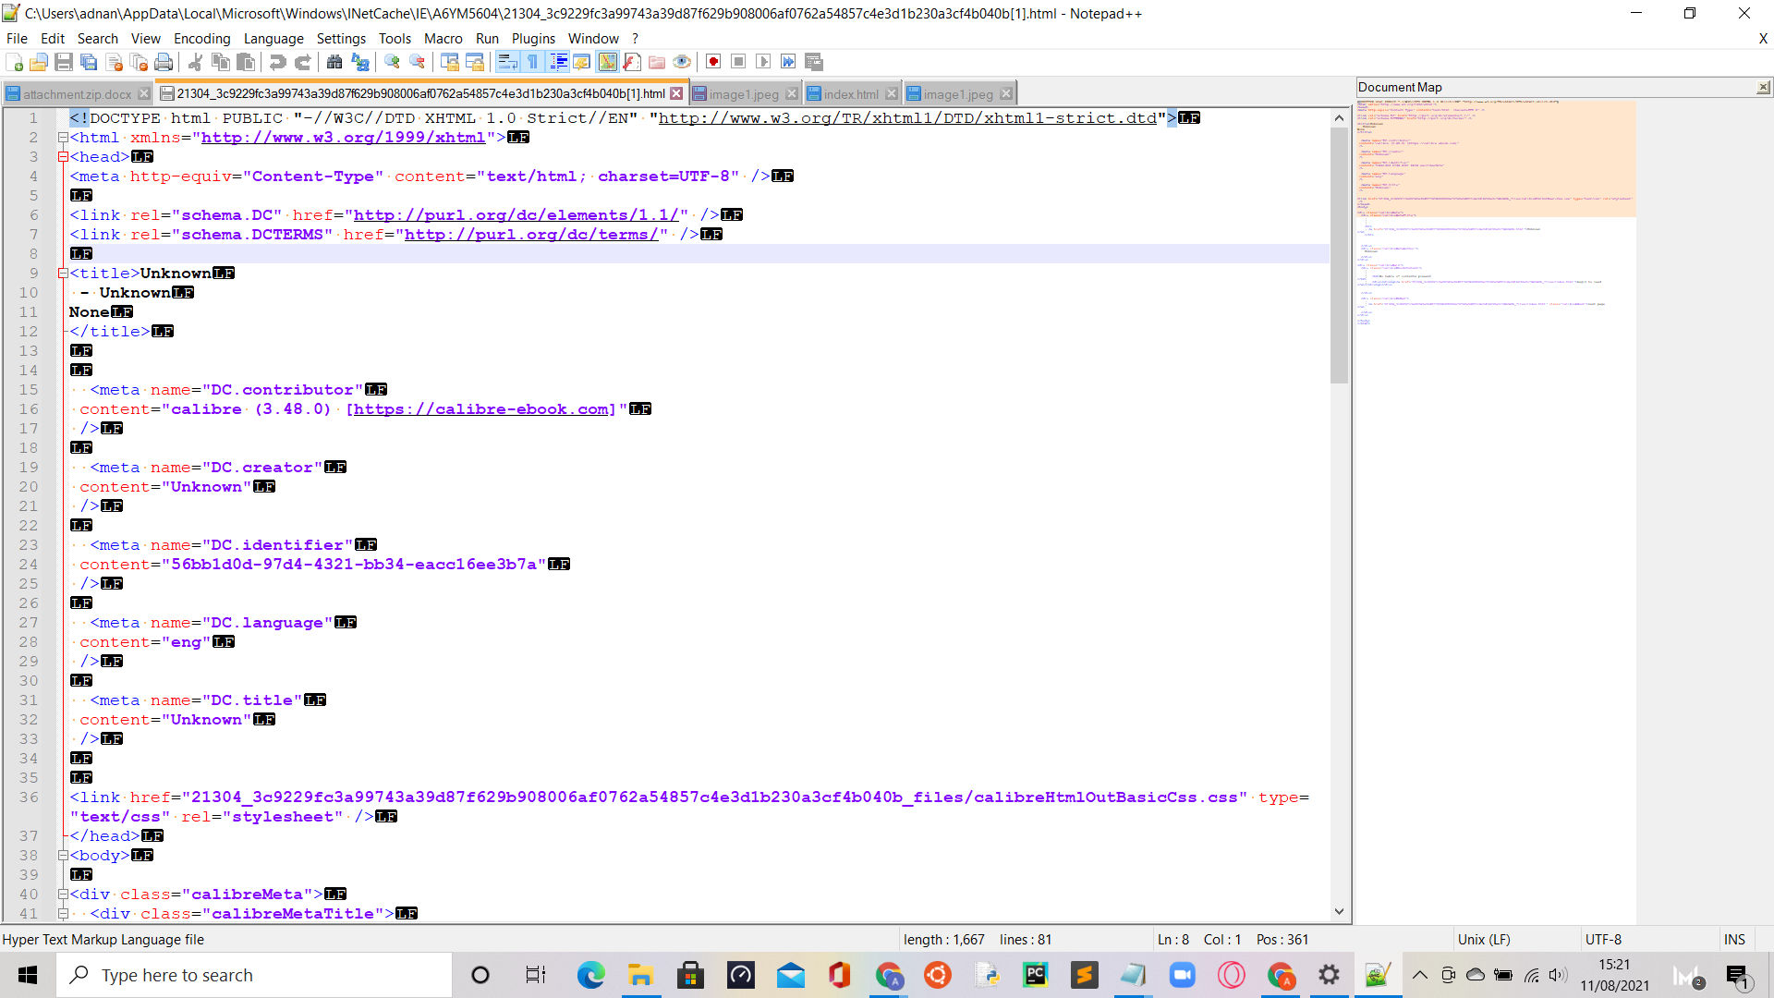

1. I opened all the available links, and found these:
2. <https://www.w3.org/TR/xhtml1/DTD/xhtml1-strict.dtd>

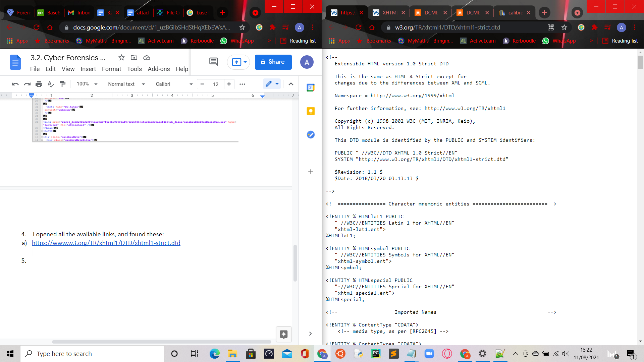

1. <https://www.w3.org/1999/xhtml/>

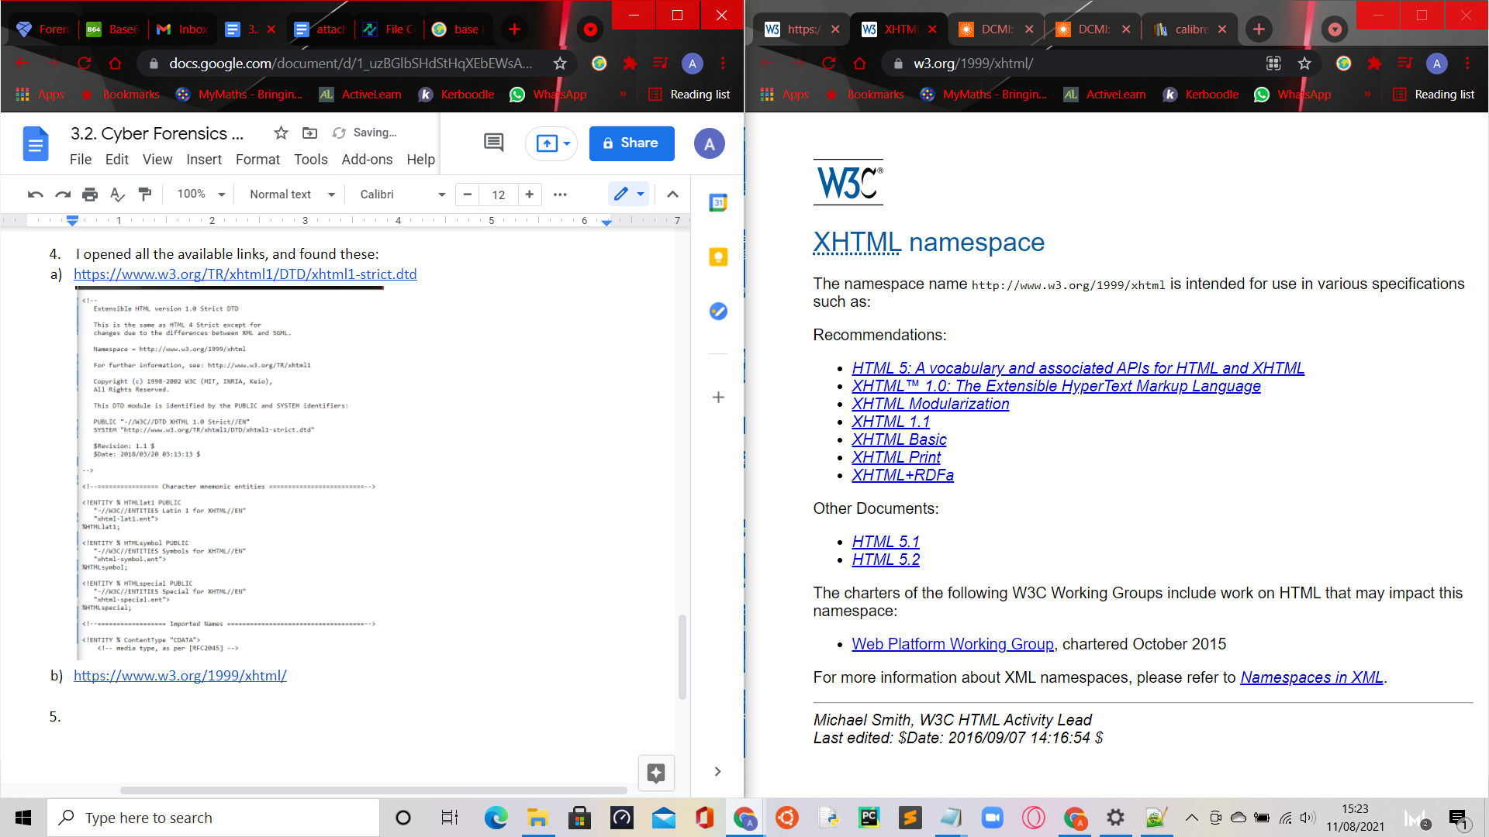

1. <https://www.dublincore.org/specifications/dublin-core/dcmi-terms/>

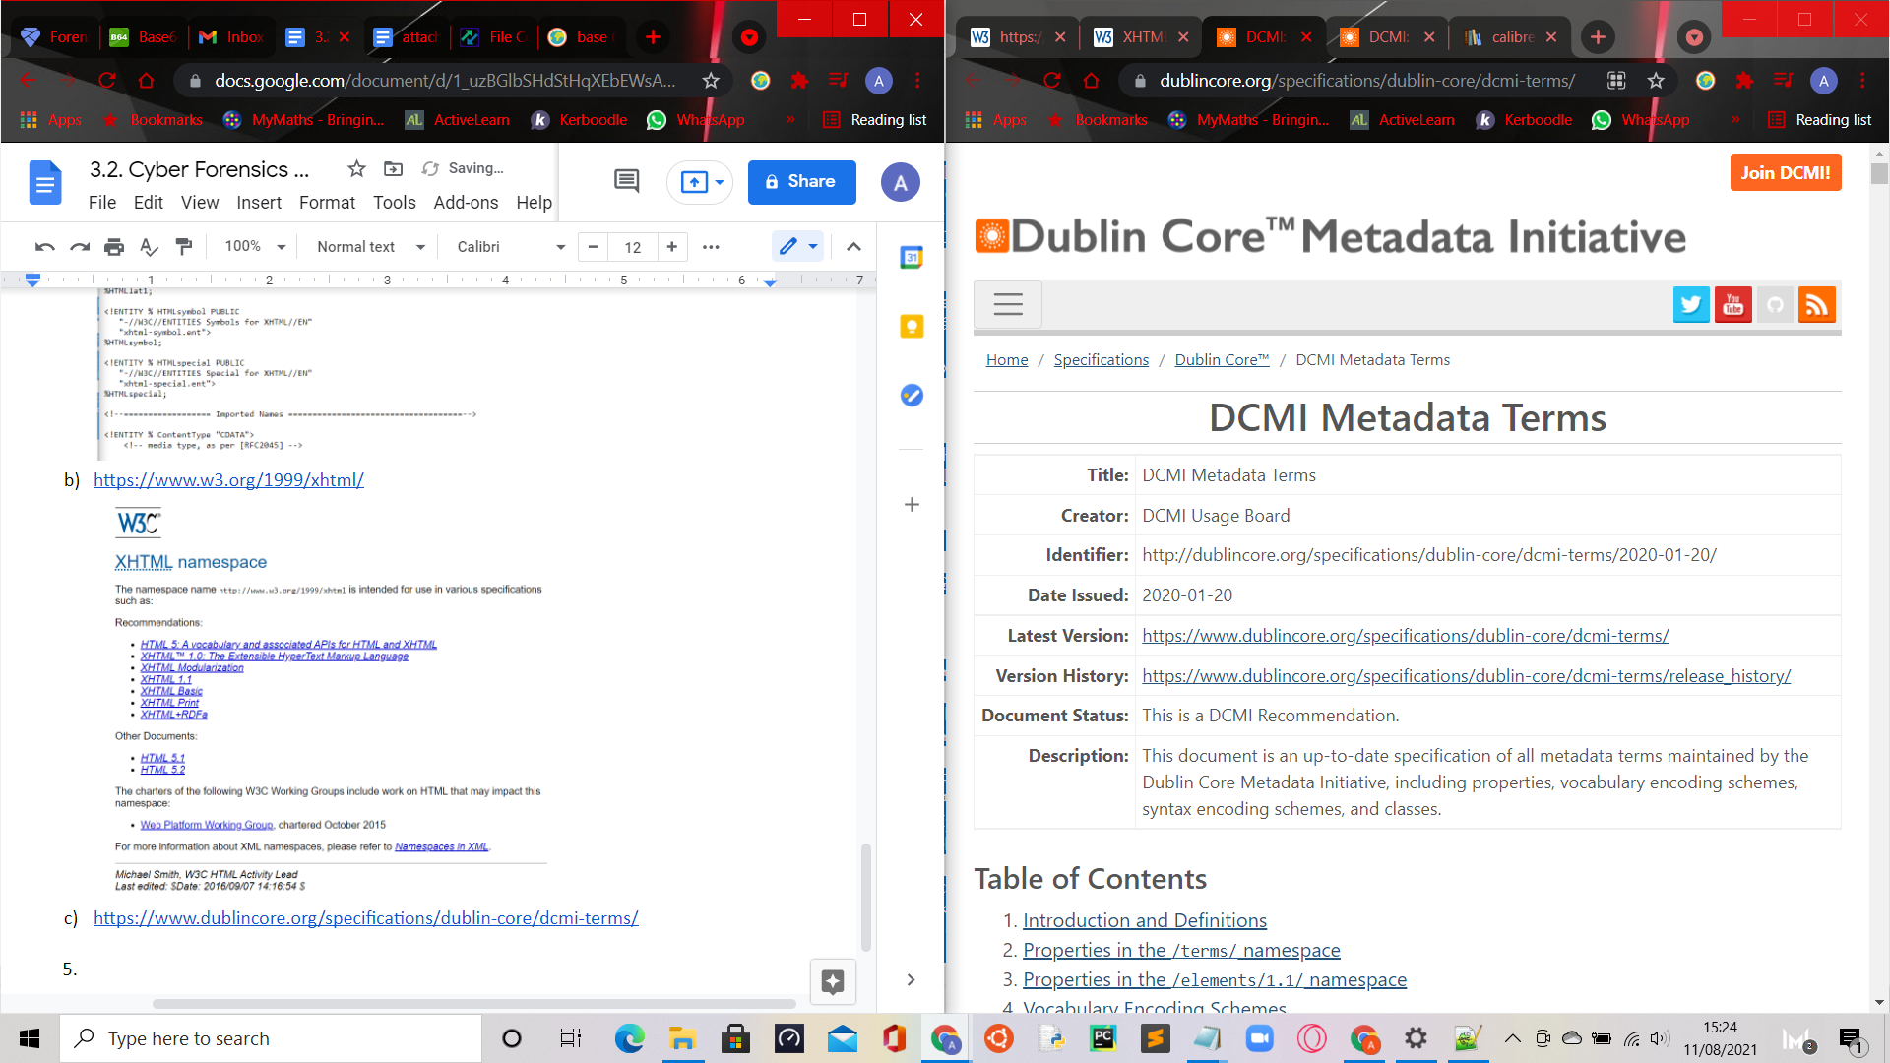

1. <https://calibre-ebook.com/>

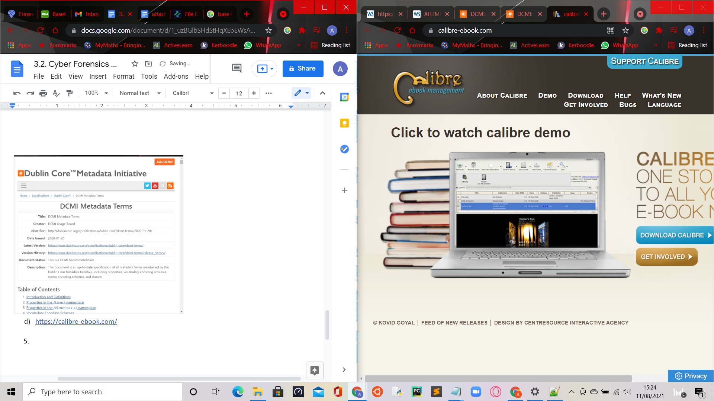

1. I believe this file is suspicious as these sites could contain potential viruses that could be imported into the company’s systems if clicked on.